Core Technology: Cyber Physical Systems

Before understanding Cyber physical systems, the reader must understand what is an embedded system.

The Industrial Internet has come about due to the rapid advancements in digital computers in all their formats and vast improvements in digital communications. These disciplines are considered separate domains of knowledge and expertise, with there being a tendency for specialization in one or the other. This results in inter-disciplinary knowledge being required to design and build products that require information processing and networking; for example, a device with embedded microprocessor and ZigBee, such as the Raspberry Pi or a smartphone. However, when we start to interact with the physical world, we have a physical domain to contend with and that requires special knowledge of that physical and mechanical domain such as that of a mechanical engineer. Therefore, it is necessary to identify early in the design process whether the product is to be an IT, network, or a physical system–or a system that has all three, physical, network, and digital processing features. If it has, then it is said to be a cyber-physical system. In some definitions, the networking and communications feature is deemed optional, although that raises the question as to how a CPS differs from an embedded system.

# Embedded Systems

Information systems, which are embedded into physical devices, are called“embedded systems”.

These embedded systems are found in telecommunication, automation, and transport systems, among many others.

Lately, a new term has surfaced, the cyber-physical systems (CPS).

This distinguishes between microprocessor-based embedded systems and more complex information processing systems that actually integrate with their environment.

A precise definition of cyber-physical systems (CPS) is that they are integrations of computation, networking, and physical processes.

Embedded computers and networks monitor and control the physical processes, with feedback loops where physical processes affect computations and vice versa.

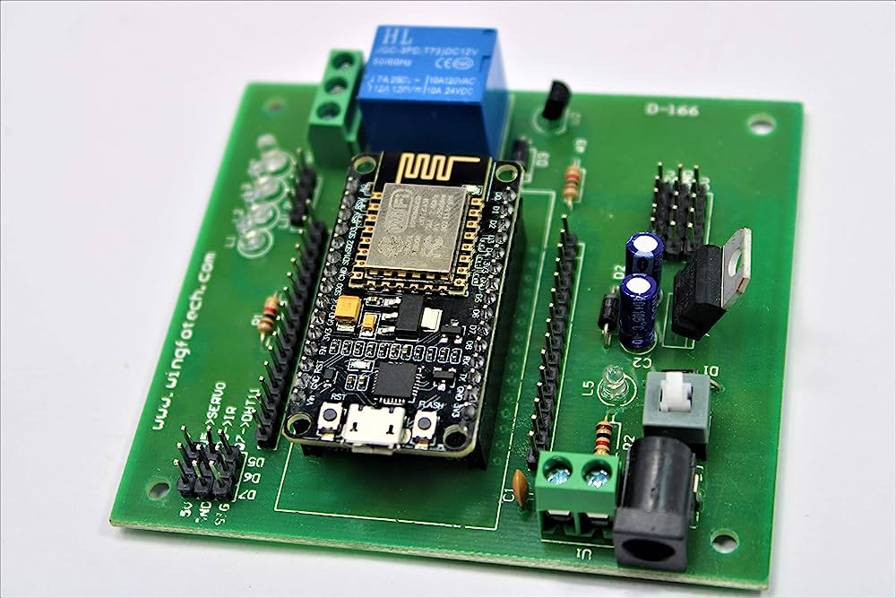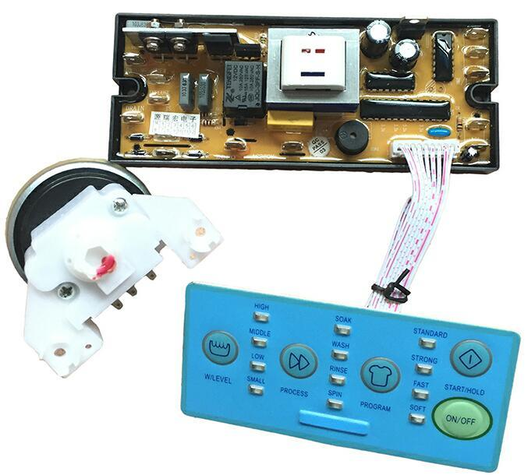

Some embedded systems

First picture shows and embedded system for a washing machine, it connects with physical devices such as button switches for taking user input, and motors for driving the wash tub.

Similarly, second figure shows a simple embedded system for switching a device on/off wirelessly.

# Cyber Physical Systems

**Sensing and actuation components**

Sensing and actuation components allow a CPS to interact with the physical world. That could involve embedded sensors that measure parameters like temperature or pressure. The data collected by these sensor networks must be processed and communicated to other parts of the system, so that appropriate decisions can be made, for example, turning a heater on or off in response to changes in temperature.

**Information processing and communication components**

These are necessary to decide how to actuate on the physical system. For example, that could involve an embedded processor that runs algorithms to make decisions based on sensor data. The processed data must then be communicated to other parts of the system to take appropriate actions.

**Control components**

Control components ensure that the system behaves as intended. That could involve a controller that regulates the flow of information and controls the system’s actuation. The control component must be designed to ensure that the system meets its objectives while considering uncertainties in the physical world.

**Interfaces with humans**

Allow people to interact with the information system. That could involve a graphical user interface that enables users to monitor the system and input commands. Again, it is essential to consider how users will interact with the system to ensure that it is easy to use and understand.

# Cyber Physical Systems (CPS)

**A cyber-physical system can be just about anything that has integrated computation, networking, and physical processes. A human operator is a cyber-physical system and so is a smart factory.**

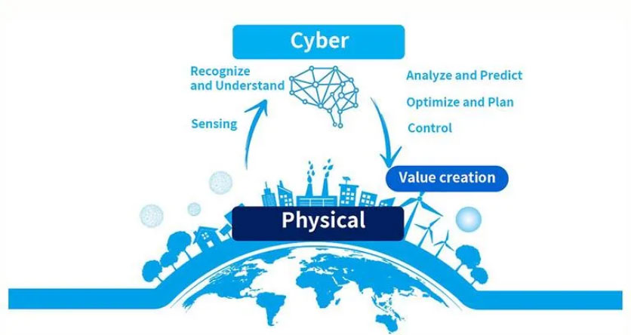Source: Toshiba

For example, a human operator has physical and cyber components. In this example, the operator has a computational facility—their brain—and they communicate with other humans and the system through HMI (human machine interface) and interact through mechanical interfaces—their hands—to influence their environment.

Cyber-physical systems enable the virtual digital world of computers and software to merge through interaction—process management and feedback control—with the physical analogue world, thus leading to an Internet of Things, data, and services.

One example of CPS is an intelligent manufacturing line, where the machine can perform many work processes by communicating with the components and sometimes even the products they are in the process of making.

An embedded system is a computational system embedded within a physical system; the emphasis is on the computational component. Therefore, we can think of all CPS as containing embedded systems, but the CPS’s emphasis is on the communications and physical as well as the computational domains.

Cyber Physical Systems (CPS) are automated systems that enable connection of the operations of the physical reality with computing and communication infrastructures [1], [2], [3].

Unlike traditional embedded systems, which are designed as stand-alone devices, the focus in CPS is on networking several devices [3].

CPS goes with the trend of having information and services everywhere at hand, and it is inevitable in the highly networked world of today.

A CPS consists of a control unit, usually one or more microcontroller(s), which control(s) the sensors and actuators that are necessary to interact with the real world, and processes the data obtained.

These embedded systems also require a communication interface to exchange data with other embedded systems or a cloud.

The data exchange is the most important feature of a CPS, since the data can be linked and evaluated centrally, for instance. In other words, a CPS is an embedded system that is able to send and receive data over a network.

The CPS connected to the Internet is often referred to as the "Internet of things".

# Critical CPS with embedded processes for Industry 4.0

# 

Here we discuss the association of Cyber-Physical Systems (CPS) with various processes supporting Industry 4.0 culture. CPS involves the integration of physical processes with computerized systems, leading to advancements in Industry 4.0. The processes allied with CPS include devices and buildings, medical processes, coordination and logistics, and transportation routes and systems. The fusion of industrial and digital technologies, such as edge/cloud computing, IIoT, AI, and autonomous robotics, can revolutionize production and realize the vision of Industry 4.0.

CPS enables internet-enabled physical objects with integrated computers and control elements like sensors and actuators. This integration allows for self-monitoring, data production, and communication with other entities. Digital twins play a significant role, where virtual replicas of tangible objects facilitate data analysis and provide real-time visibility of specialized records and processes.

The Internet of Things (IoT) and CPS have different origins, with IoT rooted in networking and IT, while CPS is driven by systems engineering and control. CPS applications contribute to energy efficiency and reduced greenhouse gas emissions. IoT use cases span across various industries, including healthcare, logistics, and manufacturing, with applications in track and trace options and structural health monitoring.

To maximize the benefits of CPS, effective communication between hardware and software components is crucial. The use of artificial intelligence can automate decision-making processes and allow employees to focus on situations that require their attention. The successful implementation of CPS relies on a hub for data interchange and collection, enhancing production processes with automation and knowledge integration.

# COMPATIBILITY OF CPS WITH INDUSTRY 4.0

* An interface to the Internet or a similar network is necessary to extend an embedded system, which is usually made of control units, sensors and actuators, to a CPS.
* In order to achieve this, there are various approaches that have been investigated in the context of this development and will be briefly presented below:
* Direct system extension
* System expansion by microcontroller board
* Extension by smart actuators and sensors

## Direct system extension

* In this individualized solution variant, the embedded system, if not available yet, is extended by a communication interface to access the Internet and the software is changed accordingly to enable communication over the internet, e.g. with the cloud.
* To this end, all the sensor signals of the system must be transmitted by the control unit to the cloud.
* Methods should be implemented to control the actuators via Internet.
* Figure 1 shows the arrangement of this solution variant.

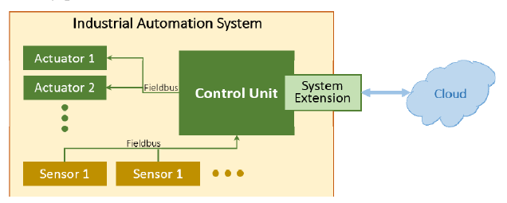

Fig. 1. Direct system control

## System expansion by microcontroller board:

* In this solution variant, a microcontroller board that has the various communication interfaces such as CAN, UART, WLAN, Ethernet, etc. is developed.
* This is connected to the embedded system and takes over the communication to the Internet or a cloud. However, this requires uniform interfaces, over which the board can be connected to the embedded system.
* The software of the board must be adjusted separately to each system.
* However, the entire code need not to be rewritten every time, but only the mapping is to be reworked accordingly so that it is relatively easy to transfer this variant to other systems.
* This arrangement is demonstrated by the following figure:

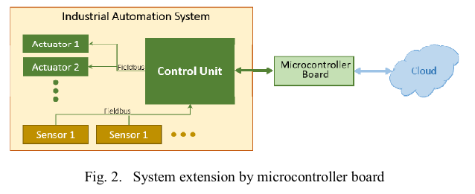

## Extension by smart actuators and sensors:

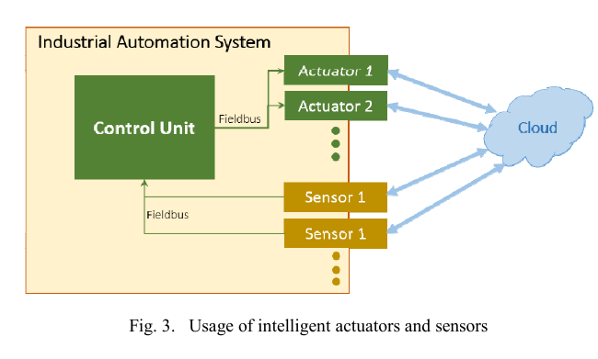

* Traditional embedded systems usually consist of a control unit, several sensors and actuators, which are connected to the control unit via field buses.
* The control unit assumes the signal processing function in such systems.
* Should smart sensors and actuators be used now, the sensors take over even the processing of the signal and the actuators independently check their current status, and correct it, if necessary.
* These sensors transmit their data to a central control unit, e.g. via field buses.
* In order to extend such a system to a CPS, it would be conceivable to also send data from the sensors and actuators, which are sent via the fieldbus, to a cloud, and process it there.
* However, a high data volume is the result here and the cost of smart sensors and actuators must not be underestimated. Figure 3 shows the extension.

# CPS reference architecture models

* Notable initiatives include Platform Industry 4.0, promoting digital transformation in German manufacturing, and the Industrial Internet Consortium (IIC), aimed at accelerating the growth of the industrial internet through collaboration with industry executives.
* Here we discuss three main CPS reference architecture models:
  + 5C Architecture,
  + RAMI 4.0
  + IIRA.
* Each model's operations are briefly described, emphasizing implementation issues behind CPS concepts.
* The section also explores the correlation among these reference architecture models and the standards and protocols implemented to ensure their correct operation.
* It details both emerging and legacy technologies, key enablers, and the security perspective for these CPS architectures.

## Overview of 5C

* The 5C Architecture is a proposal based on automation processes models, centered on data acquisition for industrial devices, with 5 levels for system operation.
* The 5C Architecture provides an implementation guide for CPS ecosystems, but some basic characteristics were not considered for its application in the I4.0 scenario.
* It is necessary to consider information flow both vertically and horizontally between products and machines, processing them according to client specifications.
* Connectivity among clients and service providers in the industry (distinct industries) is essential for I4.0 services to be connected to the Internet along with controllers, machines, products, and other objects.
* Services like stock management, load transport requests, and purchases can be automated through factory virtualization, leading to the Internet of Services (IoS), a key pillar of I4.0.
* Other reference models like RAMI 4.0 and IIRA were created to meet the needs of the current scenario and provide I4.0 standardization.

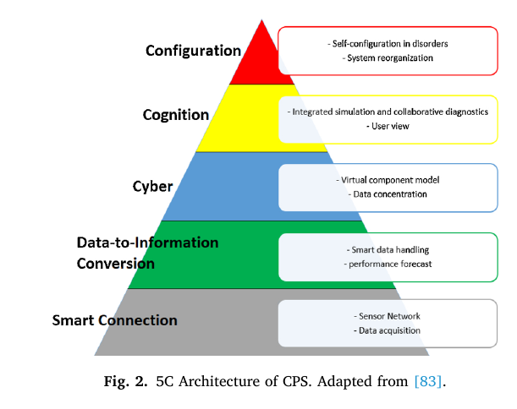

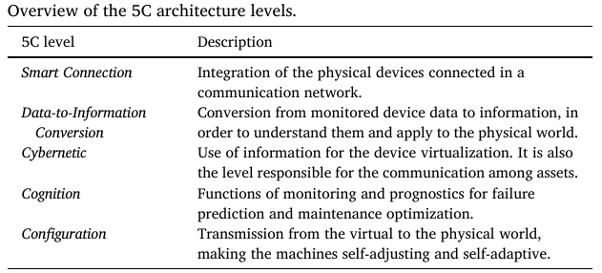

## Overview of RAMI 4.0

* RAMI 4.0 is an Architecture Reference Model for Industry 4.0, created by Platform Industrie 4.0, to define communication structures and a common language within the factory, enabling integration of IoT and services in the I4.0 context.
* RAMI 4.0 is a Service Oriented Architecture (SOA) that combines IT components to promote horizontal and vertical integration within a factory, connecting products and the Cloud.
* RAMI 4.0 is represented by a three-dimensional map with three axes: Hierarchy Levels, Product Life-cycle, and Architecture Layers.
* Axis 1 (Hierarchy Levels) focuses on flexible machines and systems, distributed functions, and improved communication among all involved participants, treating products as part of the architecture.
* Axis 2 (Product Life-cycle) describes assets from idea to production, usage, and maintenance, representing objects with value for an organization, such as devices or equipment.
* Axis 3 (CPS Proposal) encompasses the Architecture Layers and focuses on Industry 4.0 Components (I4.0C), globally and uniquely identifiable objects with communication capacity.
* I4.0C includes an asset and an Administration Shell (AS) containing relevant information for asset management, representing the physical and digital aspects of a machine, equipment, or product.
* AS serves as a standardized interface for communication networks, connecting physical entities to Industry 4.0.
* All Administration Shells (digital twins) are managed by a Superior System Administration Shell (SAS), facilitating intercommunication between them.

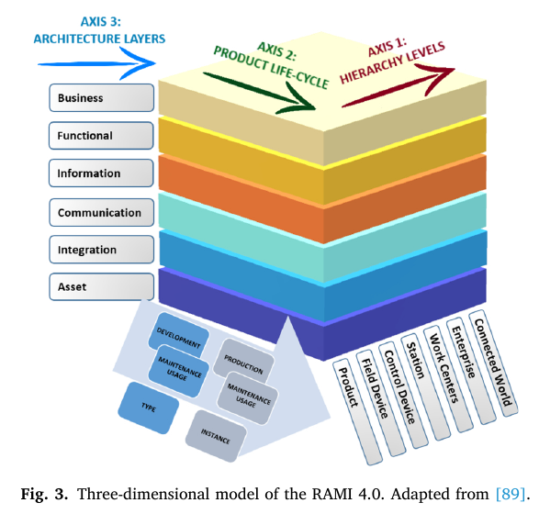

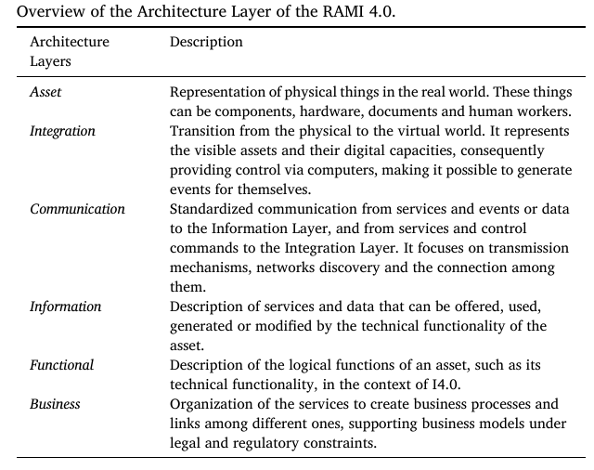

## Overview of IIRA

* IIRA (Industrial Internet Reference Architecture) is an open architecture developed by IIC (Industrial Internet Consortium) based on IIoT standards, emphasizing interoperability among industries.
* IIRA is organized into four Viewpoints: Business Viewpoint, Usage Viewpoint, Implementation Viewpoint, and Functional Viewpoint.
* The Business Viewpoint identifies participants and their business views, values, and objectives in IIoT systems.
* The Usage Viewpoint describes the IIoT system's expectations to provide the intended business objectives.
* The Implementation Viewpoint identifies the technologies required to implement the functional components, their communication schemes, and life-cycle procedures.
* The Functional Viewpoint focuses on the functional components, their inter-relation, interaction with external elements, and is divided into five domains: control, operation, information, application, and business.
* The Functional Viewpoint also includes Crosscutting Functions that enable the main system functions and System Characteristics, which are properties or emergent behaviors of the IIRA system.
* Among the Crosscutting Functions, the Connectivity function is responsible for connecting the system functions and ensuring their interaction for complete functionality

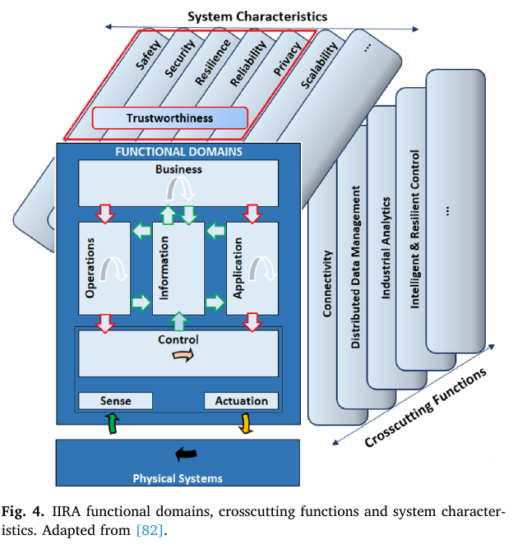

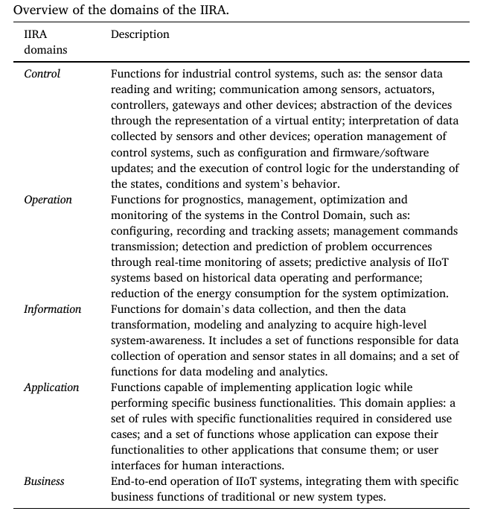

## Correlation among 5C Architecture, RAMI 4.0 and IIRA

* The mentioned architecture reference models (5C Architecture, RAMI 4.0, and IIRA) have CPS concepts but target different goals.
* The 5C Architecture focuses on assets data acquisition and processing, commonly used in embedded systems and small industrial environments.
* RAMI 4.0, based on SGAM, adapts CPS architecture for the I4.0 scenario, emphasizing manufacturing plant operation and integrating the value chain of the company.
* IIRA, based on ISO/IEC/IEEE 42010, is centered on IIoT systems concerns in all sectors, emphasizing interoperability among industries.
* There are similarities and functional mappings among the architectures, and there is correlation and interoperability among the reference models.
* RAMI 4.0 and IIRA are more discussed in the industrial community, focused on I4.0 proposals, application, services, and business ideas for integration among industries and the manufacturing sector.
* To ensure interoperability between RAMI 4.0 and IIRA, concepts like standardized functions, semantics, and unique identifiers are required.
* Identification, networking, semantics, and functional mapping are fundamental concepts for interoperability between IIoT and Industry 4.0 systems.
* Standardization of parameters allows the recognition of the same product and its respective data in both RAMI 4.0 and IIRA architectures, enabling correct interoperability.

# Case Study

PROTOTYPICAL IMPLEMENTATION OF AN INDUSTRY 4.0 APPLICATION FOR AN INDUSTRIAL COFFEE MACHINE

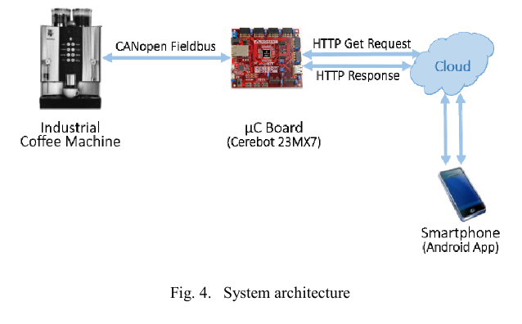

The Institute of Industrial Automation and Software Engineering (IAS) at the University of Stuttgart developed a scenario for Cyber-Physical Systems (CPS) development. They upgraded an embedded industrial coffee machine to a CPS using a microcontroller board as a cloud gateway. The coffee machine now offers various cloud-based services like remote diagnostics and software updates. The prototype's "extension by a microcontroller board" approach is advantageous as it doesn't require system rework. The microcontroller board intercepts and saves internal CAN communication in the cloud, enabling data exchange with user applications. During maintenance, CPS benefits include remote identification of defects or ingredient depletion. Furthermore, CPS allows customization of products, such as adjusting coffee temperature and strength based on user preferences through an app. The coffee machine will be connected to the cyber world through a Facebook page to network with similar machines and enable finding the nearest coffee machine offering desired products.

# Summary

* We discussed Cyber-Physical Systems (CPS) and their integration of computation, networking, and physical processes.
* The text introduces the concept of Cyber-Physical Systems (CPS), which integrate computation, networking, and physical processes.
* CPS involves embedded systems that interact with the physical world through sensors, actuators, and communication components.
* It enables the Internet of Things (IoT) and offers benefits such as remote diagnostics and customization.
* The case study of an industrial coffee machine transformed into a CPS using a microcontroller board as a cloud gateway is discussed, highlighting cloud-based services and remote maintenance.

# Important Points

* Cyber-Physical Systems (CPS) integrate computation, networking, and physical processes.
* CPS involves embedded systems that interact with the physical world through sensors, actuators, and communication components.
* CPS enables the Internet of Things (IoT) and offers benefits such as remote diagnostics and customization.
* A case study involves the transformation of an industrial coffee machine into a CPS using a microcontroller board as a cloud gateway.
* The microcontroller board enables cloud-based services and allows remote maintenance of the coffee machine.
* CPS is a key element in Industry 4.0, merging industrial and digital technologies to revolutionize production and realize the vision of Industry 4.0.
* Effective communication between hardware and software components is crucial for successful CPS implementation.
* The successful implementation of CPS relies on a hub for data interchange and collection, enhancing production processes with automation and knowledge integration.
* There are various approaches to extend an embedded system to a CPS, such as direct system extension, system expansion by a microcontroller board, and extension by smart actuators and sensors.

# References

1. Baheti, R., & Gill, H. (2011). Cyber-physical systems. The impact of control technology, 12(1), 161-166.
2. Jazdi, N. (2014, May). Cyber physical systems in the context of Industry 4.0. In 2014 IEEE international conference on automation, quality and testing, robotics (pp. 1-4). IEEE.
3. Gilchrist, A. (2016). Industry 4.0: the industrial internet of things. Apress.
4. Informer, E. (2023, June 9). What are Cyber Physical Systems? (Design Elements & Factors). ERP Information. https://www.erp-information.com/cyber-physical-systems